**See your pension online anytime, anywhere**

[**https://www.warburtonsdbpension.co.uk/**](https://www.warburtonsdbpension.co.uk/)

This is the home for all things about your pension in the Warburtons Pension and Life Assurance Plan.

You’ll find useful information in the home page as well as recent announcements and news about the plan.

To get full value out of everything available to you on the site, you’ll need to create a log in by registering your details, setting up your email address and going through a short security process. This is explained over the page. Once you log in to the secure area, you then have full access to your own personal information, so at any time you can:

|  |  |
| --- | --- |
| * **View & update** your personal information | * **Tell us** how you prefer us to contact you |
| * **View** your annual pension at date of leaving | * **Add & update** your nominated beneficiaries |
| * **View** your annual pension revalued to a current date (future development) | * **Submit** requests for pension illustrations and view the results online |
| * **Update** your address | * **Model** your benefits at retirement (future development) |
|  |  |

Turn over to see how simple it is to do……

**How to set yourself up**

1. **Step One**

Go to <https://www.warburtonsdbpension.co.uk/> and click on **Register.**

1. **Step Two**

Enter the following personal information:

* Surname
* Date of Birth
* National Insurance Number
* Mobile Telephone number (if you do not have a mobile phone number, you can enter a landline number instead)
* Personal Email address

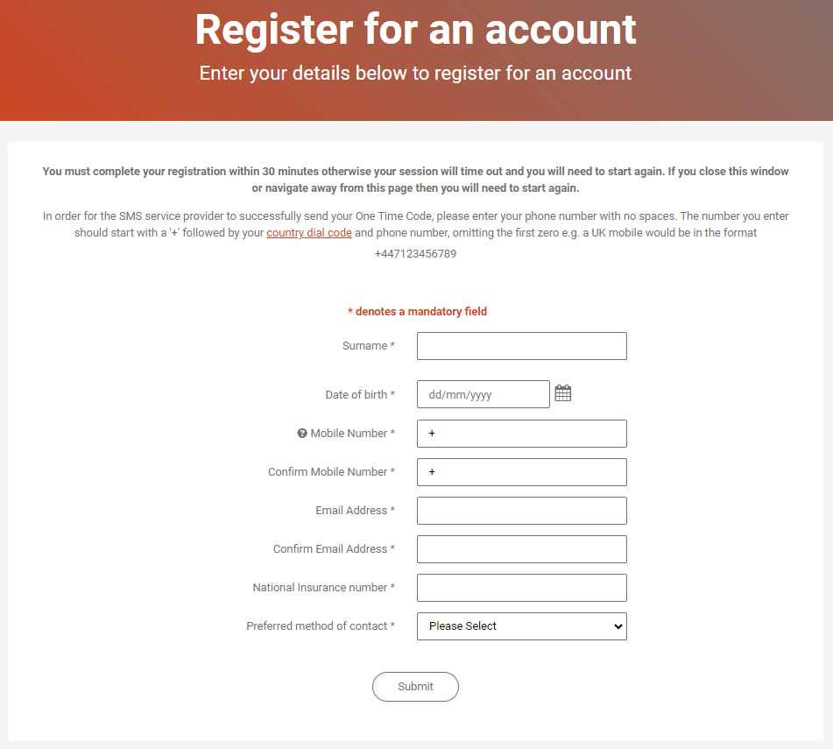

1. **Step Three**

You’ll be asked to choose a username and password. Your username must be at least 8 characters, and can include upper- and lower-case letters, numbers, or symbols. Your password must be at least 9 characters, include both upper- and lower-case letters, at least one number and one special character or symbol. Once added, click ‘**Submit**’.

1. **Step Four**

A One Time Code will be sent by text message to the mobile phone number you provided in Step 2 or by text to speech to a landline phone number. Please enter the One Time Code within 30 minutes to complete registration and click ‘**Submit**’. If you don’t complete your registration within the time slot, you’ll be returned to the start of the process.

**What happens next?**

Tell us about any changes to your personal details and review the pension information that we hold for you.

Each time you log in a One Time Code will be sent to you by text message or text to speech as an additional layer of security to protect your information.

**If you have any problems with logging into the site you can either:**

**Tel : 0207 082 6433 ; or**

**Email :** [**warburtons@hymans.co.uk**](mailto:warburtons@hymans.co.uk)